Middle East Technical University

Electrical and Electronics Engineering

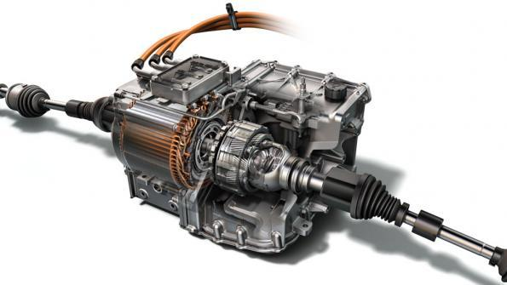

EE462 – Utilization of Electrical Energy

Laboratory Manual

2nd Edition – May 2017

**Table of Contents**

**1.** **Introduction** 4

**2.** **Laboratory Policy** 8

**3.** **Experiment 1: Fan Load Driven by Variable Frequency Drive (VFD)** 9

**3.1.** **Objective** 9

**3.2.** **Equipment** 9

**3.3.** **Procedure** 12

**3.3.1.** **Preparation** 12

**3.3.2.** **Inlet Damper Control** 12

**3.3.3.** **Outlet Damper Control** 13

**3.3.4.** **Inverter Driven Speed Control** 13

**3.4.** **Results** 14

**3.5.** **Conclusions** 14

**3.6.** **Appendix** 15

**4.** **Experiment 2: Variable Frequency Drive (VFD) Driven Crane Hoist with Speed Feedback** 17

**4.1.** **Objective** 17

**4.2.** **Equipment** 17

**4.3.** **Procedure** 19

**4.3.1.** **Preparation** 19

**4.3.2.** **VFD with Vector Control** 19

**4.3.3.** **VFD with V/f Control** 20

**4.3.4.** **Direct On-line Control (DOL)** 20

**4.3.5.** **Crane-Hoist Measurements** 20

**4.4.** **Results** 21

**4.5.** **Conclusions** 21

**5.** **Experiment 3: Performance of an Induction Motor Drive under Different Load Characteristics** 22

**5.1.** **Objective** 22

**5.2.** **Equipment** 22

**5.3.** **Procedure** 25

**5.3.1.** **Preparation** 25

**5.3.2.** **Pump load characteristics** 25

**5.3.3.** **Electric traction load characteristics** 26

**5.3.4.** **Motor drive effects** 26

**5.4.** **Results** 26

**5.5.** **Conclusions** 27

# **Introduction**

Welcome to Laboratory of “EE 462 Utilization of Electrical Energy” course. During this laboratory, you will experience using commercial electrical drives. In order to demonstrate electric motor drives’ capabilities and limitations, different kind of mechanical load is preferred for each of the experiments.

Spurred by advances in power electronics, adjustable-speed electric drives now offer great opportunities in a plethora of applications: pumps and compressors to save energy, precision motion control in automated factories, and wind-electric systems to generate electricity, to name a few. A recent example is the commercialization of hybrid-electric vehicles. Figure 1.1 shows the photograph of a hybrid arrangement in which the outputs of the internal combustion (IC) engine and the electric drive are mechanically added in parallel to drive the wheels. Compared to vehicles powered solely by gasoline, these hybrids reduce fuel consumption by more than **50 %** and emit far fewer pollutants. Honda Insight Hybrid 2006 is reported to consume 3.56 liters per 100 km (66 miles/gallon).

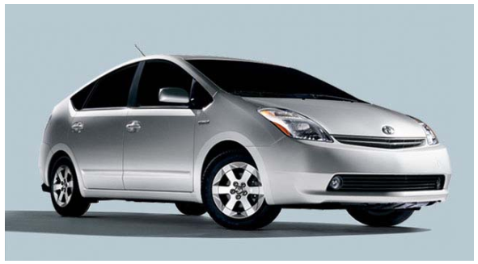

Figure 1.1: Photograph of a hybrid-electric vehicle (Toyota Prius)

Electric machines have now been in existence for over a century. All of us are familiar with the basic function of electric motors: to drive mechanical loads by converting electrical energy. In the absence of any control, electric motors operate at essentially a constant speed. For example, when the compressor motor in a refrigerator turns on, it runs at a constant speed. Traditionally, motors were operated uncontrolled, running at constant speeds, even in applications where efficient control over their speed could be very advantageous. For example, consider the process industry (like oil refineries and chemical factories) where the flow rates of gases and fluids often need to be controlled. As Figure 1.2.a illustrates, in a pump driven at a constant speed, a throttling valve controls the flow rate. Mechanisms such as throttling valves are generally more complicated to implement in automated processes and waste large amounts of energy. In the process industry today, electronically controlled variable-frequency drives (VFD), shown in Figure 1.2.b, control the pump speed to match the flow requirement. Systems with adjustable-speed drives are much easier to automate, and offer much higher energy efficiency and lower maintenance than the traditional systems with throttling valves.

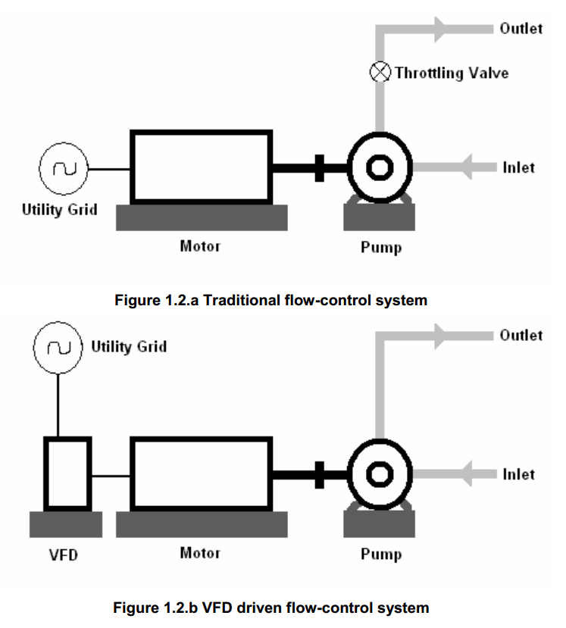 

(a) (b)

Figure 1.2: (a) Traditional flow-control system, (b) VFD driven flow-control system

These improvements are not limited to the process industry. Electric drives for speed and position control are increasingly being used in a variety of manufacturing, heating, ventilating and air conditioning, and transportation systems.

Figure 1.3 shows the block diagram of an electric-motor drive, or for short, an electric drive. In response to an input command, electric drives efficiently control the speed and/or the position of the mechanical load, thus eliminating the need for a throttling valve like the one shown in Figure 2.a. The controller, by comparing the input command for speed and/or position with the actual values measured through sensors, provides appropriate control signals to the power-processing unit (PPU) consisting of power semiconductor devices. As Figure 1.3 shows, the power-processing unit gets its power from the utility source with single-phase or three-phase sinusoidal voltages of a fixed frequency and constant amplitude. The power-processing unit, in response to the control inputs, efficiently converts these fixed-form input voltages into an output of the appropriate form (in frequency, amplitude, and the number of phases) that is optimally suited for operating the motor.

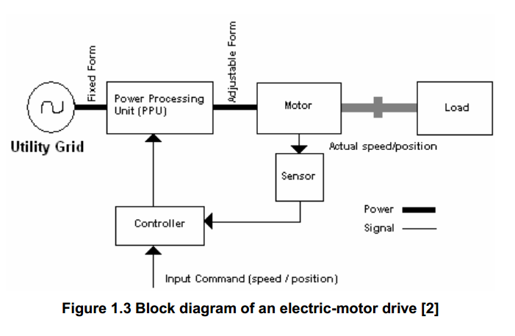

Figure 1.3: Block diagram of an electric motor drive

The input command to the electric drive in Figure 1.3 may come from a process computer, which considers the objectives of the overall process and issues a command to - control the mechanical load. However in general-purpose applications, electric drives operate in an open-loop manner without any feedback.

Electric drives are increasingly being used in most sectors of the economy. Figure 1.4 shows that electric drives cover an extremely large range of power and speed - up to 100 MW in power and up to 80,000 rpm in speed.

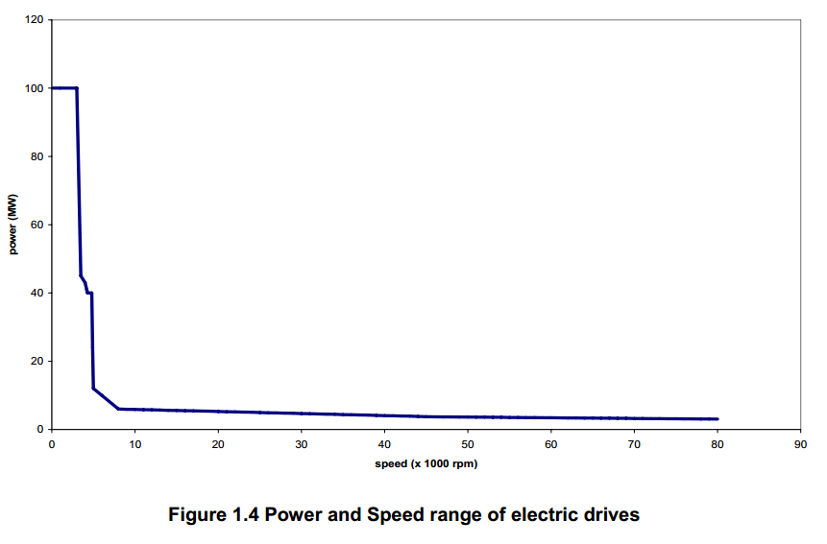

Figure 1.4: Power and speed range of electric motor drives

Due to the power-processing unit, drives are not limited in speeds, unlike line-fed motors that are limited to 3,600 rpm with a 60-Hz supply (3,000 rpm with a *50-* Hz supply). A large majority of applications of drives are in a low to medium power range, from a fractional kW to several hundred kW. Some of these application areas are listed below:

**Process Industry:** agitators, pumps, fans, and compressors  
**Machining:** planers, winches, calendars, chippers, drill presses, sanders, saws, extruders, feeders,  
grinders, mills and presses.  
**Heating, Ventilating and Air Conditioning:** blowers, fans, and compressors  
**Paper and Steel Industry:** hoists, and rollers  
**Transportation:** elevators, trains, and automobiles  
**Textile:** looms  
**Packaging:** shears  
**Food:** conveyors, and fans  
**Agriculture:** dryer fans, blowers, and conveyors  
**Oil, Gas, and Mining:** compressors, pumps, cranes, and shovels  
**Residential:** heat pumps, air conditioners, freezers, appliances, and washing machines

# **Laboratory Policy**

* Throughout this laboratory, you will encounter real loads, be careful. Never lose coordination with your co-workers. Wear your coveralls, helmets and protective gloves whenever required (Figure 2.1).
* All the experiments must be performed and reports returned, to receive a passing grade. Each student will attend the experiments in their own group.
* Please read and study the laboratory manual before each experiment. You will be asked questions during the experiments. There will also be a quiz at the end of each experiment.
* Each student must prepare their reports for each experiment ***individually*** and upload them to ODTUClass as pdf files. You don’t have to bring a hard copy**.** Deadline for report submission is 10 days after the date the experiment is performed, 23:59. No late submission is allowed.
* Grading will be as follows:
  + Quiz: 30%
  + Performance: 40%
  + Report: 30%
* All reports will be checked for plagiarism using Turnitin software and any copied reports will be graded zero including laboratory performance. Be aware that we have a large collection of previous years’ reports.

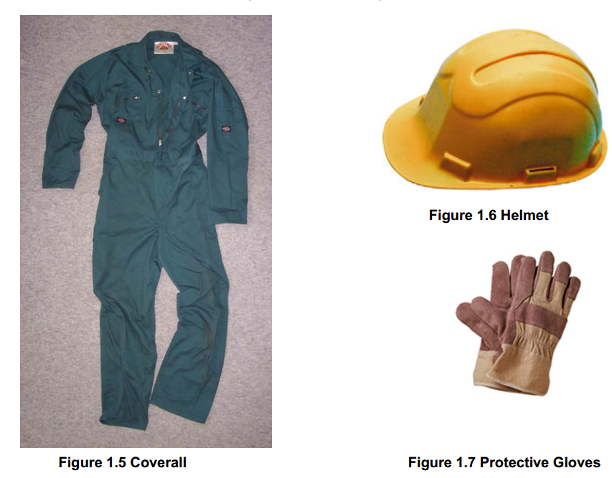



Figure 2.1: Coverall, helmet and protective gloves

# **Experiment 1: Fan Load Driven by Variable Frequency Drive (VFD)**

# **Objective**

* Observing the energy consumption of wind blower system in three cases:
  + Flow rate controlled by ***Inlet Damper***
  + Flow rate controlled by ***Outlet Damper***
  + Flow rate controlled by the help of ***Inverter driven AC Machine***
* Experiencing different drive control strategies with ***different V/f curves***
* Observing the load profile of high-performance centrifugal fan.
* Getting familiar with commercially available dc link converters

# **Equipment**

Fans can be thought of as low pressure air pumps that utilize power from a motor to output a volumetric flow of air at a given pressure. A propeller converts torque from the motor to increase static pressure across the fan rotor and to increase the kinetic energy of the air particles. All of the aerodynamic aspects of a fan are exhibited in a fan curve such as is shown in Figure 3.4. Characteristics of our fan used in this experiment is also given in the Appendix. The fan performance curve is one of the few curves that are read from right to left, because you start with healthy aerodynamic flow and follow it through to aerodynamic stall. However, in contrast to an airplane wing, there is life after stalling in a fan. A stalled fan continues to deliver air, but at an increased static pressure and a decreased volumetric flow rate, and also at the cost of an increase in noise. If noise is not a consideration, the fan can be utilized in this condition. An energy viewpoint is helpful in understanding the fan performance curve. For example, at the shut-off point, the fan is in the condition of the maximum potential energy. At free delivery, the fan is in the condition of the maximum kinetic energy. Although neither of these extreme conditions are likely to occur in practice, they can be useful parameters in comparing fans. The governing principle in fan selection is that any given fan can only deliver one flow at one pressure in a particular system. This operating point" is determined by the intersection of the fan static pressure curve and the system pressure curve. Figure 3.4 illustrates the operating points of both high and low resistance systems. It is best to select a fan that will give an operating point being toward the high flow, low pressure  
end of the performance curve to maintain propeller efficiency and to avoid propeller stall. Fan loads usually absorb ***torques changing w.r.t. square of shaft speed.***

Equipment used in the experiment is given in Table 3.1. Block Diagram of the experiment set-up is given in Figure 3.1. A picture of the experimental setup is displayed in Figure 3.2. A three-phase wattmeter should be connected between the supply and inverter. Driven AC machine and centrifugal fan coupled to its shaft are shown in Figure 3.3. Note the motor is mounted on 4 springs. These springs are used to absorb vibration of the system, since it shaft speed reaches 4200 rpm when rotated at 70 Hz. The fan/ system interaction is also shown in Figure 3.4.

Table 3.1: Equipment used in the experiment

|  |  |  |  |  |
| --- | --- | --- | --- | --- |
| **Equipment** | **Type** | **Rating** | **Company** | **Notes** |
| Asynchronous m/c | Squirrel cage | 3kW/400V | Siemens | Drives wind blower |
| Drive unit | MicroMaster 440 | 3kW/400V | Siemens | Drives AC machine |
| Centrifugal fan | BG100L-B14 | 3kW/2890rpm | ZIEHL-ABEGG |  |
| 3-phase wattmeter | AC | 500V/20A | Hioki |  |
| Anemometer |  |  |  |  |
| Air duct | Rect. Cross-section |  |  |  |

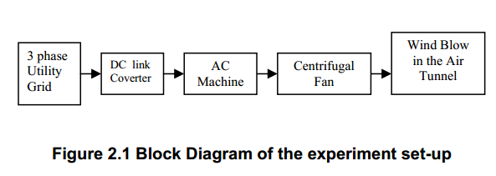

Figure 3.1: Block diagram of the experimental setup

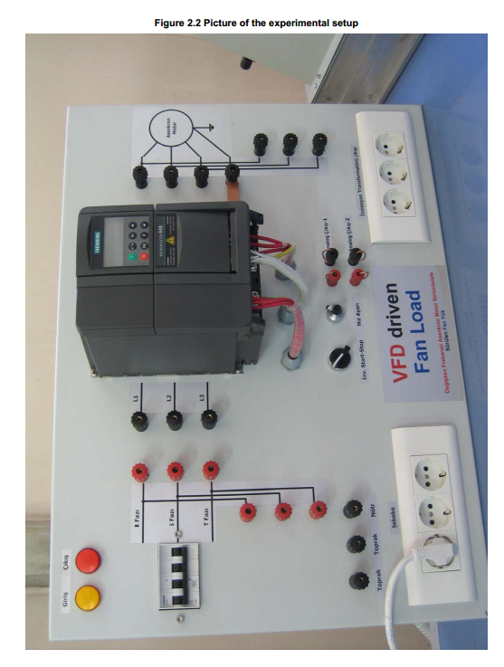

Figure 3.2: Picture of the experimental setup

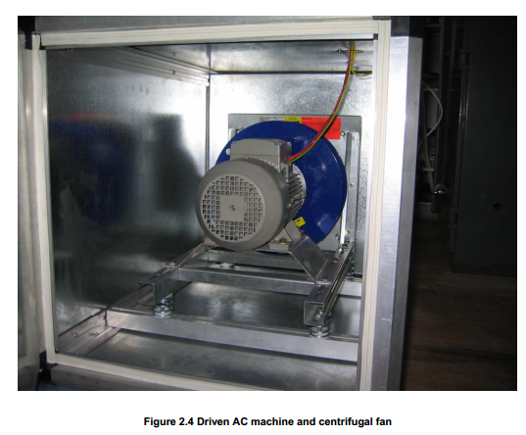 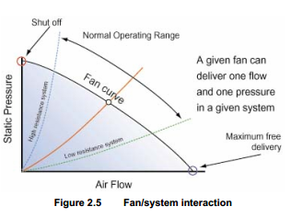

Figure 3.4: Fan/system interaction

Figure 3.3: AC m/c and the centrifugal fan

# **Procedure**

## **Preparation**

There are three types of control which can be applied for flow rate control. These are Inlet Damper Control, Outlet Damper Control, Inverter driven A/C Machine Control. All of these three methods will be employed and system performance will be measured. Inlet Damper and Outlet Damper Control are going to be performed under constant frequency and voltage output of the inverter. Therefore, parameters of the inverter should be set as follows:

|  |  |  |
| --- | --- | --- |
| **Parameter** | **Value** | **Comment** |
| P0010 | 1 | Write access for motor data |
| P304.In000 | 400 | Rated voltage (volts) |
| P310.In000 | 70 | Rated frequency (Hz) |
| P311.In000 | 4004 | Rated shaft speed (rpm) |
| P0010 | 0 | Remove Write access |
| P1300.In000 | 0 | Linear V/f control selected |

Now turn on the inverter by start/stop button on the panel, and set the frequency to 70 Hz by using the potentiometer next to it. Frequency value can be observed either on P0000 or r0024.

## **Inlet Damper Control**

Check inlet and outlet damper s of the wind tunnel. Set both dampers to **“completely open”** position. Change the wind flow rate by using ***inlet damper only***up to completely closed inlet damper position in several steps. In each step, measure the following parameters:

* Supply Inverter input voltage (from Wattmeter)
* Supply line Inverter input current (from Wattmeter)
* Inverter input power (from Wattmeter)
* Inverter output frequency (r0024)
* Inverter output voltage (r0025)
* Inverter output line current (r0027)
* Estimated electromechanical torque (r0031)
* Inverter output power (r0032)
* Outlet air flow rate (anemometer)

***NOTE:*** During air flow rate measurement you should take 3 or 4 measurements for different positions of the air velocity measurement probe and note average of these measurements. This is essential when there is a non-uniform wind velocity field at the outlet.

## **Outlet Damper Control**

Check inlet and outlet dampers of the wind tunnel. Set both dampers to **“completely open”** position. Change the wind flow rate by using ***outlet damper only***up to completely closed inlet damper position in several steps. In each step, measure the same parameters in Part 3.3.2.

## **Inverter Driven Speed Control**

Check the inlet and outlet dampers of the wind tunnel. Set both dampers to **“completely open”** position. In each part, change the wind flow rate by using ***the potentiometer dedicated to controlling the inverter output frequency,*** measure the same parameters in Part 3.3.2. The drive parameter set at the beginning will generate the V/f curve linear up to rated frequency.

* Linear V/f, frated = 70 Hz

|  |  |  |
| --- | --- | --- |
| **Parameter** | **Value** | **Comment** |
| P1300.In000 | 0 | Linear V/f control selected |

* Parabolic V/f, frated = 70 Hz

|  |  |  |
| --- | --- | --- |
| **Parameter** | **Value** | **Comment** |
| P1300.In000 | 2 | Parabolic V/f control selected |

* Linear V/f, frated = 50 Hz

|  |  |  |
| --- | --- | --- |
| **Parameter** | **Value** | **Comment** |
| P0010 | 1 | Write access for motor data |
| P310.In000 | 50 | Rated frequency (Hz) |
| P311.In000 | 2890 | Rated shaft speed (rpm) |
| P0010 | 0 | Remove Write access |
| P1300.In000 | 0 | Linear V/f control selected |

* Parabolic V/f, frated = 50 Hz

|  |  |  |
| --- | --- | --- |
| **Parameter** | **Value** | **Comment** |
| P1300.In000 | 2 | Parabolic V/f control selected |

* Sensorless Vector Control, frated = 50 Hz

|  |  |  |
| --- | --- | --- |
| **Parameter** | **Value** | **Comment** |
| P1300.In000 | 20 | Sensorless vector control |

# **Results**

1. Tabulate the data obtained in each step.
2. Plot the inverter output power vs outlet air flow rate graphics with the data obtained in parts 3.3.2, 3.3.3 and 3.3.4 (only Linear V/f, frated = 70 Hz), on the same graph.
3. Plot the inverter output torque vs inverter output speed with data obtained in part 3.3.4 (only Linear V/f, frated = 70 Hz) to obtain the fan load characteristics.
4. Plot the inverter output voltage vs inverter output frequency with data obtained in parts 3.3.4 to display V/f curves for different drive control strategies.
5. Plot the inverter output power vs inverter output frequency with data obtained in parts 3.3.4.

# **Conclusions**

1. Compare the efficiencies of flow rate control strategies found in Q.II of the results section and comment.
2. Compare the efficiencies of different drive control strategies found in Q.IV of the results section. Which one would be the best choice for fan load?

# **Appendix**

**ZIEHL – ABEGG Centrifugal Fan Static Pressure vs Flow Rate Characteristics**

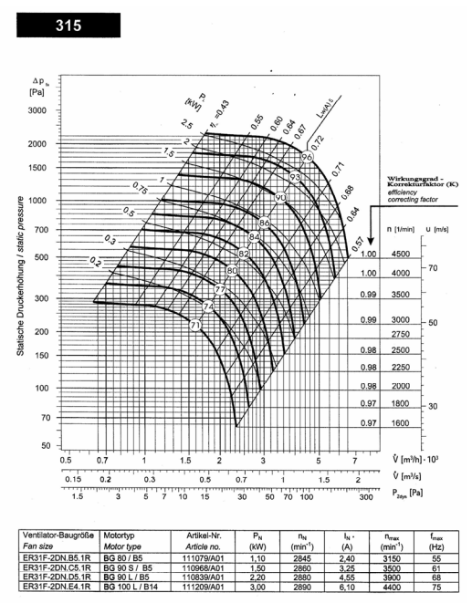

**Energy Conservation in Blower Systems**

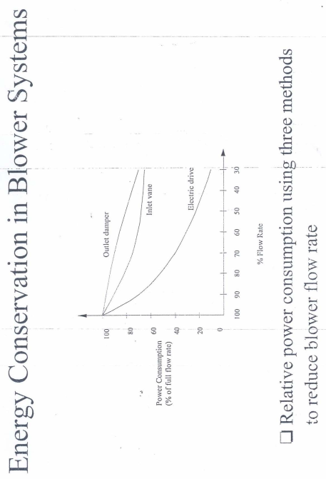

# **Experiment 2: Variable Frequency Drive (VFD) Driven Crane Hoist with Speed Feedback**

# **Objective**

* Observing performance of the dc-link converter driving a crane-hoist at variable-frequency
* Obtaining the load profile of crane-hoist under various speeds
* Observing the need of a braking-resistor when lowering a massive load
* Getting familiar with commercially available variable-frequency drives

# **Equipment**

A **crane** is a tower (Figure 4.1) or derrick equipped with cables and pulleys that is used to raise (ascend) and lower (descend) materials. Cranes are commonly used in the construction industry and in manufacturing heavy equipment. Construction cranes are usually temporary structures, either fixed to the ground or mounted on a purpose-built vehicle. Cranes may either be controlled from an operator in a cab that travels with the crane, by a pushbutton pendant control station, or by infrared or radio control. Where a cab operator is employed, workers on the ground will communicate with the operator through a system of standardized hand-signals; an experienced crew can position loads with great precision using only these signals. Constant speed crane-hoist operation results in ***constant torque load.*** Lowering the load at constant speed (overhauling) is an important operation mode of a crane-hoist.

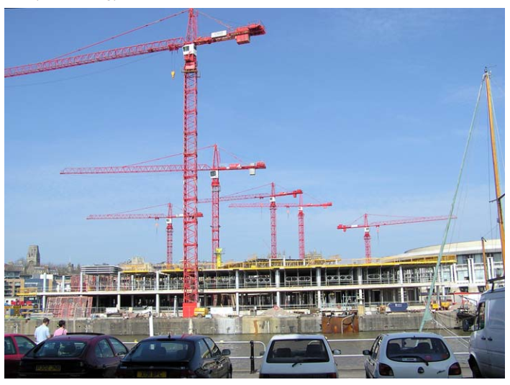 

Figure 4.1. Tower cranes

The crane hoist to be operated in this experiment is given in Figure 4.2. This is a monorail system with two motors. One of the motors is used for vertical motion (hoist machine), whereas the other one is employed for horizontal motion. The hoist machine is driven with Siemens Micromaster. Shaft speed of the motor is reduced by gearbox and wheel. Precise speed and position control is obtained by the help of closed-loop speed control. Control panel is also shown in Figure 4.2. Hoist motor nameplate parameters are given in Table 4.1, and crane-hoist nameplate parameters are given in Table 4.2.

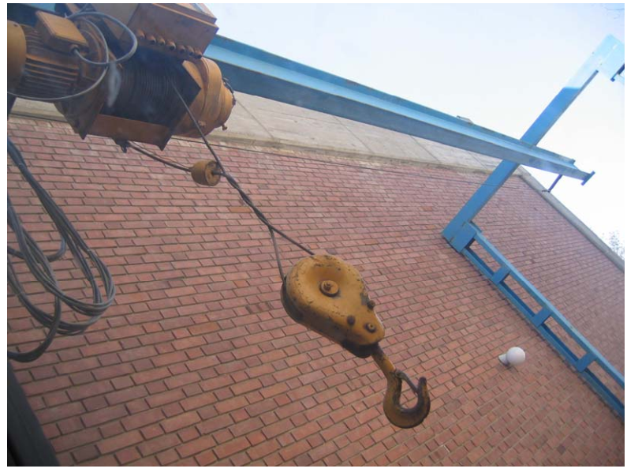 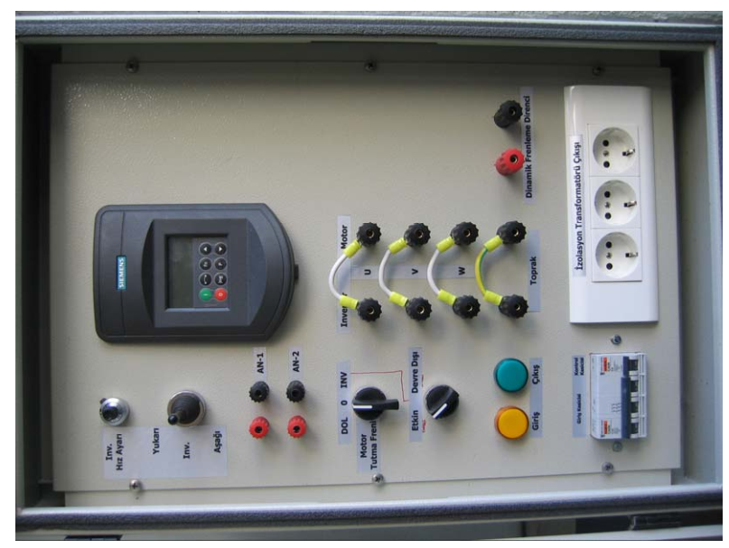

Figure 4.2. Crane Hoist to be operated in the experiment and its control panel

Table 4.1. Hoist motor rated parameters Table 4.2 Crane-hoist nameplate parameters

|  |  |  |  |  |
| --- | --- | --- | --- | --- |
| **Voltage (V)** | 220/380 |  | **Type** | C100 |
| **Current (A)** | 9,2/5,3 |  | **Capacity** | 1 TON |
| **Power (kW)** | 2,2 |  | **Elevation height** | 7,5 m |
| **Power factor** | 0,82 |  | **Motor Power** | 2,2 kW |
| **Speed (rpm)** | 1400 |  | **RPM** | 1500 |
| **IP** | 55 B5 |  | **Production Date** | 2000 |
| **Cl.** | F |  |  |  |

# **Procedure**

## **Preparation**

Crane-hoist experiment has both electrical and mechanical prerequisites. Please check all of them and inform your assistant if any of the requirements is not met, before starting the experiment.

* Connect the braking resistor to the port of ***“Dinamik Frenleme Direnci”*.** Two single phase load resistances should be connected in series to get enough value of resistance. Also connect a series ampermeter to measure the braking current.
* Set **DOL-0-INV** switch to **INV** position. (DOL means Direct-On-Line, whereas INV stand for dc-link converter control).
* Set **Etkin-Devre Dışı** switch to **Etkin.** (This will enable motor holding brake. When the load is at zero speed, required torque is generated by the brake, not by the motor and the dc-link converter). Set **Giriş Kesicisi** to conducting mode.
* All motor parameters are previously set in the dc-link converter, but you should check once more the parameters at Table 3.1 are entered to Micromaster (refer to parameter list of Siemens Micromaster).
* Lower the hook. Attach the load tank with given steel cords. Fill the load tank with **0.48 m3** water.

## **VFD with Vector Control**

Set the following parameter of Micromaster:

|  |  |  |
| --- | --- | --- |
| **Parameter** | **Value** | **Comment** |
| P1300.In000 | 21 | Vector control with sensor selected |

* Set the speed of the DC-link converter to **50 Hz** by using the knob names **“Inv. Hız Ayarı”.** Raise the load by setting **“Inv.”** to **“Yukarı”** position. While load tank is moving upward **at a constant speed**, measure the following parameters:
* Dc-link converter output frequency (r0024)
* Dc-link converter output line-to-line voltage (r0025)
* Dc-link converter output line current (r0027)
* Estimated output torque (r0031)
* Dc-link converter output power (r0032)
* Braking resistance current (ampermeter)
* Total elapsed time during motion (chronometer)
* Lower the load by setting **“Inv.”** to **“Aşağı”** position. While load tank is moving downward **at a constant speed**, measure the same parameters.
* Repeat the same procedure at **25 Hz** for both raising and lowering.
* Repeat the same procedure at **5 Hz** for both raising and lowering.

## **VFD with V/f Control**

Set the following parameter of Micromaster:

|  |  |  |
| --- | --- | --- |
| **Parameter** | **Value** | **Comment** |
| P1300.In000 | 0 | Linear V/f control selected |

* Measure the same procedure in 4.3.2 at **50 Hz** for both raising and lowering.
* Repeat the same procedure at **25 Hz** for both raising and lowering.
* Repeat the same procedure at **5 Hz** for both raising and lowering.

## **Direct On-line Control (DOL)**

Set **DOL-0-INV** switch to **DOL** position. Now the crane hoist is directly driven by 400 Vrms, 3-phase, 50 Hz supply. External remote control unit should be connected to control the crane-hoist. **Raise** and **lower** the load using the remote control unit. For this case, ***only total elapsed time*** can be measured since other measurements are taken from Micromaster.

## **Crane-Hoist Measurements**

* Measure the **gearbox ratio** of the crane-hoist system. For this purpose, you may operate the dc-link converter at constant **rated speed** for a period of time. Measure the **elapsed time** and **revolutions** of the wheel. This will help you finding gearbox ratio since you know the rated speed of the motor.
* Measure the **wheel radius** by the help of **vertical displacement** of the load and **number of revolutions**.
* Measure the **resistance** of the dynamic braking resistor.

# **Results**

1. Tabulate the data obtained.
2. Plot output torque vs frequency, and obtain crane-hoist load characteristics. The frequency axis should include both positive (raise load) and negative (lower load) values.
3. Plot output power vs output frequency.
4. Find the linear speed of load at each step. Calculate total weight of load in Newtons. Calculate the mechanical power delivered to the load by using its linear speed and weight.
5. Estimate the overall efficiency of gearbox.
6. Find the load inertia ***seen***by the motor. Neglect inertia of the gearbox and the wheel.
7. Plot the dynamic braking resistance current vs frequency.

# **Conclusions**

1. Check the linear speeds of the load in VFD control (vector control, 50 Hz) and DOL control. Comment on the performance of VFD driven crane-hoist.
2. Comment on the closed-loop speed control. Would you prefer an open-loop system with lower cost?
3. Comment on operation of dynamic braking resistor. What would be the result if it had been  
   absent?
4. Could the VFD driven crane hoist system be operated at zero speed without motor holding brake? If yes, how?
5. Crane-hoist system used throughout the experiment has two motors (2 degrees of freedom). Hence, reachable space is a “plane”. If you are supposed to build a tower crane, how many motors/dc-link converters would you use for this tower crane? Comment on the  
   ratings of the dc-link converter(s).

# **Experiment 3: Performance of an Induction Motor Drive under Different Load Characteristics**

# **Objective**

* Observing the performance of an induction motor drive with closed-loop speed control under the following load characteristics:
* Pump
* Electric traction
* Observing the waveforms of variable frequency AC motor drives
* Observing the effects of using VFDs to both motor and grid
* Learning about advantages and disadvantages of variable frequency drives

# **Equipment**

In this experiment, a laboratory setup (normally used as a wind energy system simulator) will be utilized, which is composed of two machines: a permanent magnet synchronous machine (PMSM) and an induction machine (IM), both of which can be used in motoring mode as well as generating mode. The photograph of the machines which are coupled mechanically is shown in Figure 5.1. The machines are connected to commercial AC drive units from Emerson. The electrical panel where the drive units are placed is also shown in Figure 5.2. The block diagram of the electrical drive and motor stage is shown in Figure 5.3. The PMSM is connected to the grid with a back-to-back converter which is composed of two drive units. The IM is connected to the grid with only one drive unit which is two-quadrant. In this experiment, **PMSM will be used as a generator to simulate the load**, and **IM will be used as the motor to be driven with closed-loop speed control**. The PMSM will be driven with torque control to obtain the load characteristics mentioned above.

The experimental setup includes a professional control and measurement system including data acquisition (DAQ) boards, sensors, communication modules and a human machine interface (HMI) built on Labview from National Instruments. The picture of the interface which will be used in this experiment is shown in Figure 5.4. The measurements that are available on the setup are also shown in Figure 5.5.

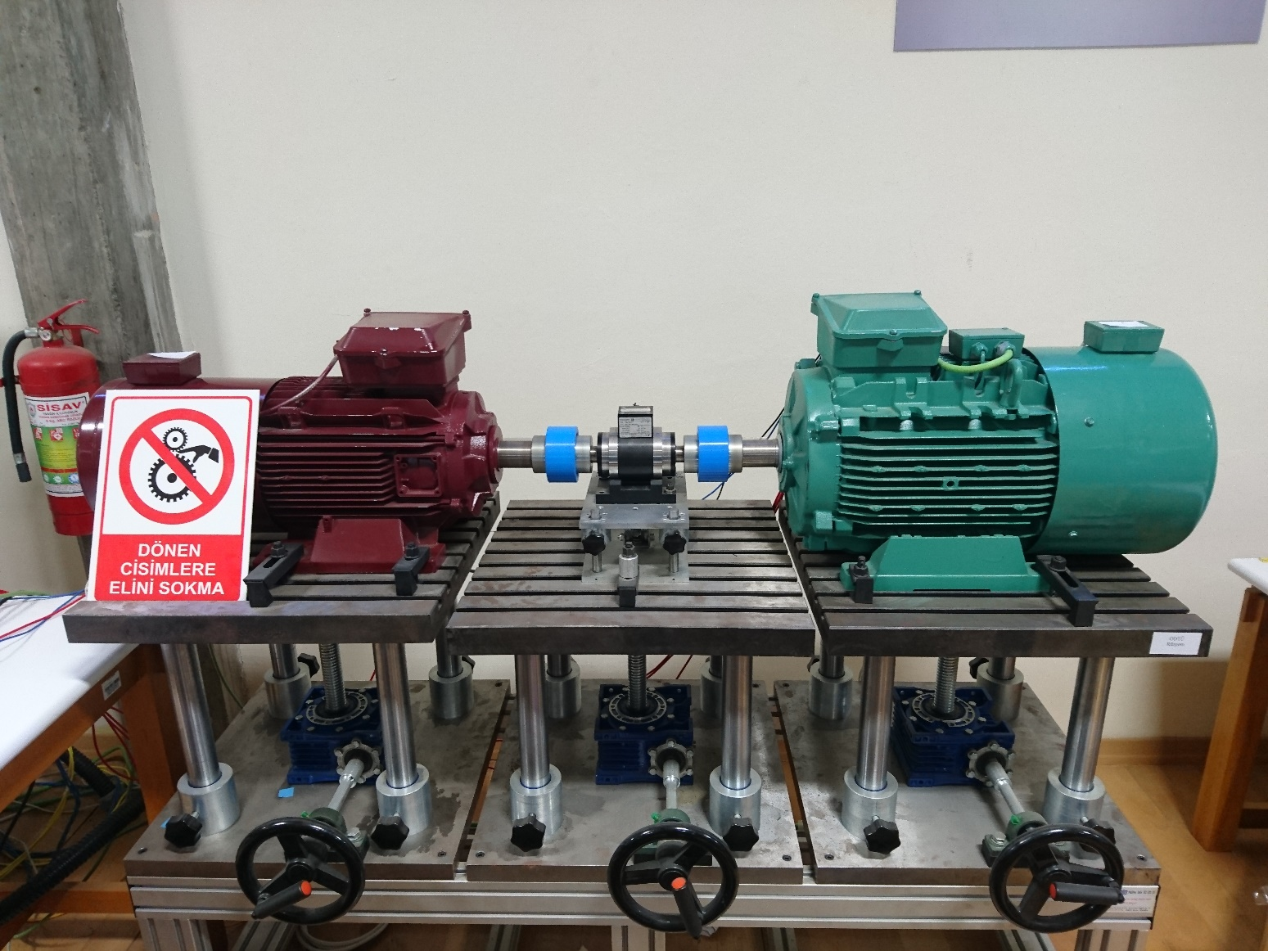

Figure 5.1. The machine set (left: PMSM, right: IM)

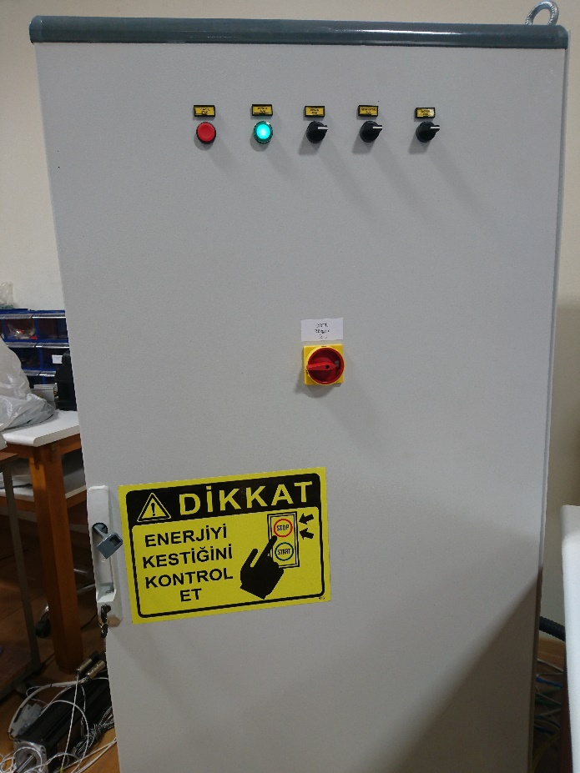 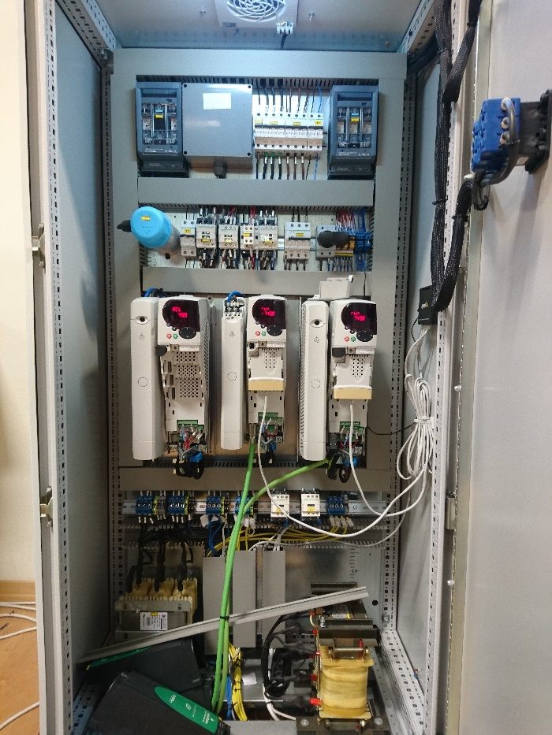

Figure 5.2. The electrical panel where the drive units are placed



Figure 5.3. The block diagram of the electrical drive and motor stage

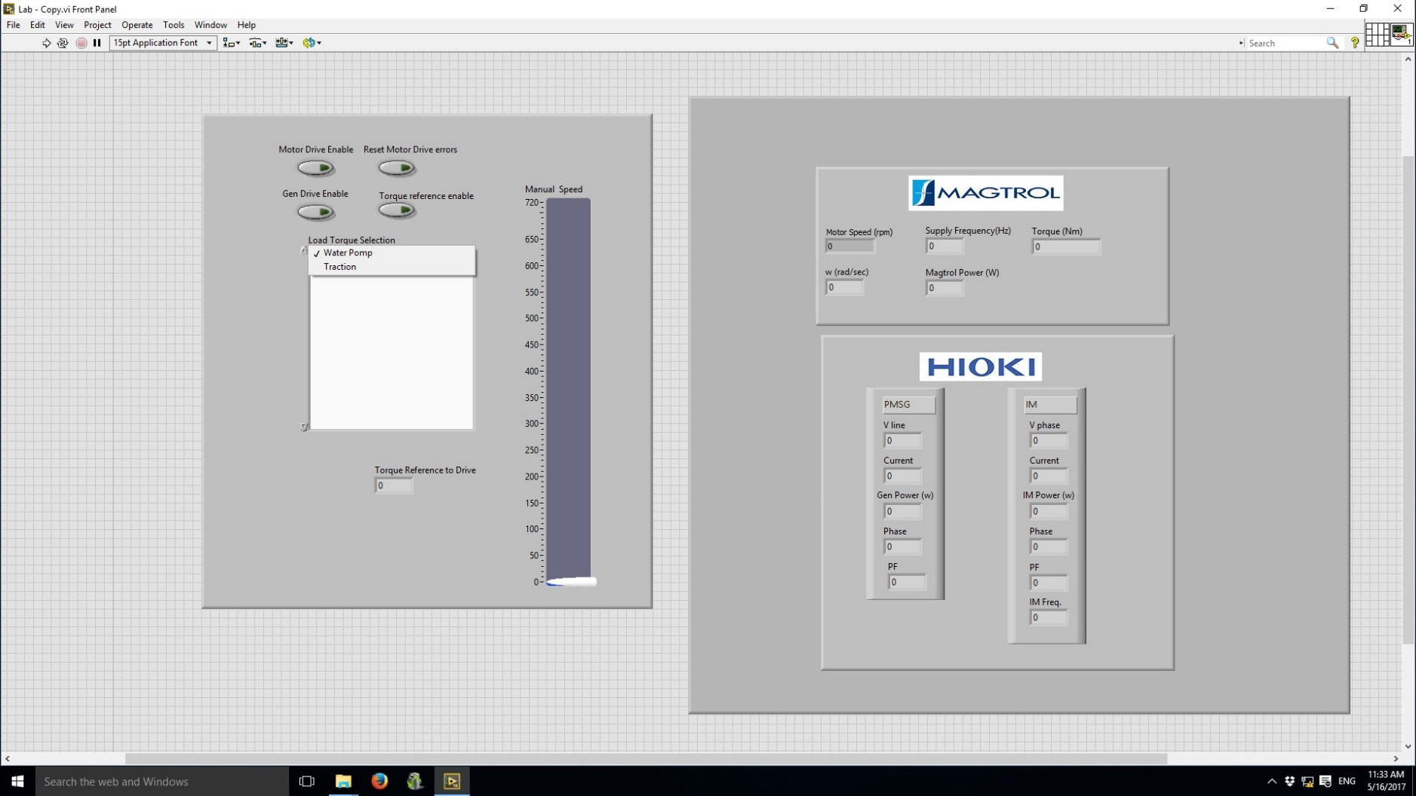

Figure 5.4. The HMI used in the experiment



Figure 5.5. The measurements that are available on the experimental setup

# **Procedure**

## **Preparation**

Investigate the experimental setup and each equipment. Open the Labview interface dedicated to this experiment and investigate the measurements and commands that will be used. In each step, the corresponding load torque curve should be selected from **Load Torque Selection** and the speed can be controlled with the bar named as **Speed Control**. For each load, several speed references will be applied to the motor drive and the following measurements will be taken:

* Shaft torque, T (interface)
* Shaft speed, N (interface)
* Drive input active power, P1 (PQ analyzer)
* Drive input reactive power, Q1 (PQ analyzer)
* Motor input active power, P2 (interface)
* Motor power factor (interface)
* Motor terminal voltage, V (interface)
* Drive frequency, f (interface)

## **Pump load characteristics**

Select **Pump** from **Load Torque Selection** on the interface. Apply the speed commands listed in the datasheet to the IM drive from the interface separately and obtain the measurements stated in 5.3.1.

## **Electric traction load characteristics**

Select **Traction** from **Load Torque Selection** on the interface. Repeat the procedure in 5.3.2.

## **Motor drive effects**

* Select **Traction** from **Load Torque Selection** on the interface. Apply rated speed command (720 rpm).
* Start the motor and observe the **motor line-to-line voltage** on the oscilloscope during acceleration (transient state). Comment on the variation.
* At steady state, record the **motor line-to-line voltage** waveform and **motor** **line current** waveform on the oscilloscope. Comment on the waveforms.
* At steady state, observe and record the **motor earth current** waveform on the oscilloscope and comment. Notice that, to be able to investigate this current, the recording should be performed with a time scale of near switching period.
* At steady state, observe and record the **grid side line current** waveform on PQ analyzer and comment. Check the **harmonic components** of the grid side line current from the PQ analyzer and record the percent magnitudes of the harmonics listed in the datasheet. Record also the **THD** of current.

# **Results**

1. Tabulate the data obtained in 5.3.2 and 5.3.3.
2. For each step and each load, calculate the motor output power, motor efficiency, drive efficiency and overall efficiency. Tabulate the results.
3. For each load, plot output torque against speed and obtain the load characteristics, separately.
4. Plot the active power at the motor terminals against speed for different loads on the same graph.
5. For each load, plot motor efficiency, drive efficiency and overall efficiency against speed on the same graph, separately.
6. Plot the motor terminal voltage against drive frequency for the different loads on the same graph.
7. Plot the power factor against speed for the different loads on the same graph.
8. Include the recorded motor line-to-line voltage waveform, motor line current waveform, motor earth current waveform and grid side line current waveform, in 5.3.4.
9. Write down the grid side line current THD and the harmonic components recorded in 5.3.4.

# **Conclusions**

1. Comment on the torque-speed characteristics obtained in Q.III of results section. Briefly explain the actual characteristics (in case we were using real loads) and compare them with your results.
2. Compare the efficiencies of the motor and the drive, obtained in Q.V of results section. Comment.
3. Compare the efficiency of the drive for different loads, obtained in Q.V of results section. Comment.
4. Comment on the variations of motor voltage against frequency, obtained in Q.VI of results section. Are they different from constant Volts/Hertz operation?
5. Comment on the variations of motor power factor, obtained in Q.VII of results section. If the motor were a PMSM, how would it change?
6. Comment on the motor line-to-line voltage waveform and motor line current waveform (Q.VIII of the results section). How would they look like if the motor drive were absent (direct on-line control)?
7. Comment on the motor earth current waveform (Q.VIII of the results section). Would it be present if the motor drive were absent (direct on-line control)? What are its adverse effects?
8. Comment on the grid side line current waveform and its THD. Is the THD value acceptable? Explain. How would it change if the motor drive were absent (direct on-line control)?
9. Comment on the harmonic components on the grid side line currents. Are they expected? Explain.